                                                                                                                    

Tanta University

Faculty of Computer science and informatics

**TAGTEAM UI/UX PROJECT REPORT**

**Submitted by:**

Eman Ali Ragab Kotb

Mohamed Salah Shehata

**Under Guinness of:**

Eng / Omar Khaled

2025

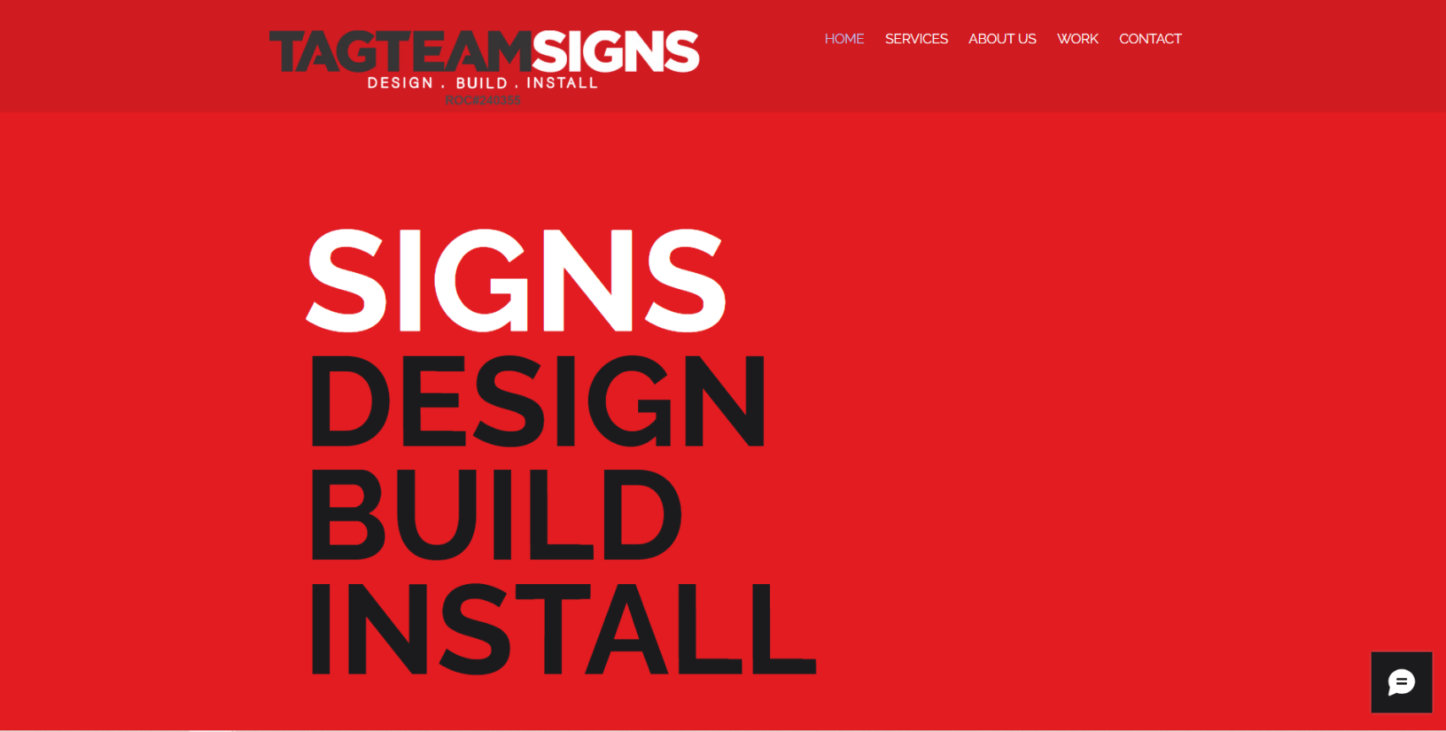

* **Bad Things in the Real Website**

1. **Visual Fatigue & Accessibility (Color Choice):**

* **The Issue:** The bright, highly saturated red background is overwhelming. It causes "eye strain" and "visual vibration," making it difficult for users to look at the screen for long periods.
* **HCI Principle:** Accessibility and User Comfort.

1. **Lack of Clear Call-to-Action (CTA):**

* **The Issue:** The most important thing a business website should do is tell the user what to do next. The original has no buttons. A user must hunt through the small navigation links to find a way to contact the company.
* **HCI Principle:** Usability and Goal Completion.

1. **Poor Visual Hierarchy:**

* **The Issue:** The headline ("SIGNS DESIGN BUILD INSTALL") is so massive that it competes with the logo. Everything is "shouting" at the same volume. There is no clear path for the eye to follow.
* **HCI Principle:** Visual Hierarchy (Guiding the user's eye).

1. **Low Information Density & Value Proposition:**

* **The Issue:** The site uses 100% of the "above the fold" space to say four words. It doesn't tell the user who they are, why they are good, or where they work.
* **HCI Principle:** Recognition vs. Recall (The user shouldn't have to guess what we do).

1. **Navigation Proximity:**

* **The Issue:** The navigation links are tiny and tucked away in the corner, far from the giant focal point of the text, making them feel disconnected.

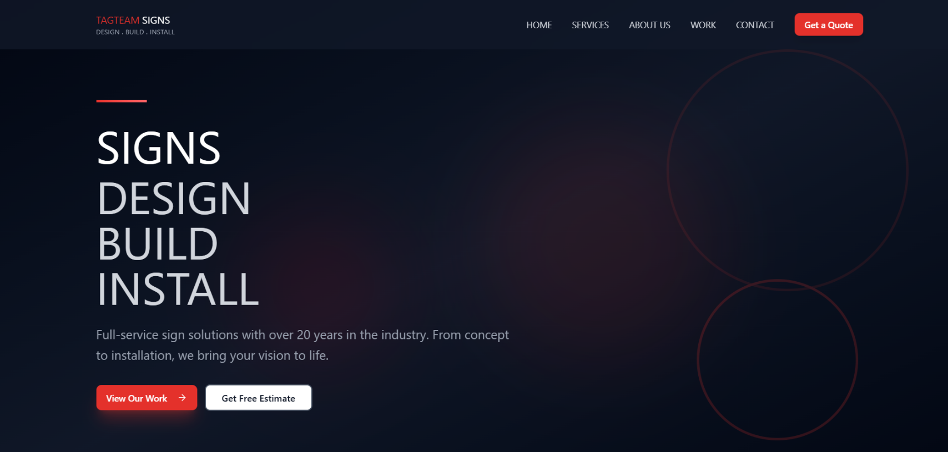

* **How we fix these issues**

Here is how we applied HCI solutions to the problems identified:

1. **Improved Color Contrast and Aesthetics:**
   * **What we did:** Switched to a dark, professional "Dark Mode" palette.
   * **Why it works:** It reduces eye strain and makes the red accents (brand color) pop much more effectively. It creates a "premium" feel that builds trust.
2. **Implementation of Primary and Secondary CTAs:**
   * **What we did:** Added "Get a Quote" in the header and two prominent buttons ("View Our Work" and "Get Free Estimate") in the hero section.
   * **Why it works:** According to **Fitts's Law**, making targets (buttons) large and easy to reach improves usability. we've given the user a clear "conversion path."
3. **Refined Typographic Hierarchy:**
   * **What we did:** Resized the main headline and added a **sub-headline** ("Full-service sign solutions with over 20 years...").
   * **Why it works:** This provides "Context." The user now understands the company's experience and services within 3 seconds of landing on the page.
4. **Balance and Composition:**
   * **What we did:** we moved the text to the left and used abstract circular shapes on the right to balance the "negative space."
   * **Why it works:** It follows the **"F-Pattern" or "Z-Pattern"** of how humans scan websites. Users look at the top left (logo), scan across (nav), and then read the headline on the left.
5. **Enhanced Branding:**
   * **What we did:** Placed the logo in the top-left corner, which is the standard "mental model" users have for finding the "Home" link.
   * **Why it works:** It satisfies **Consistency and Standards** (Heuristic #4).

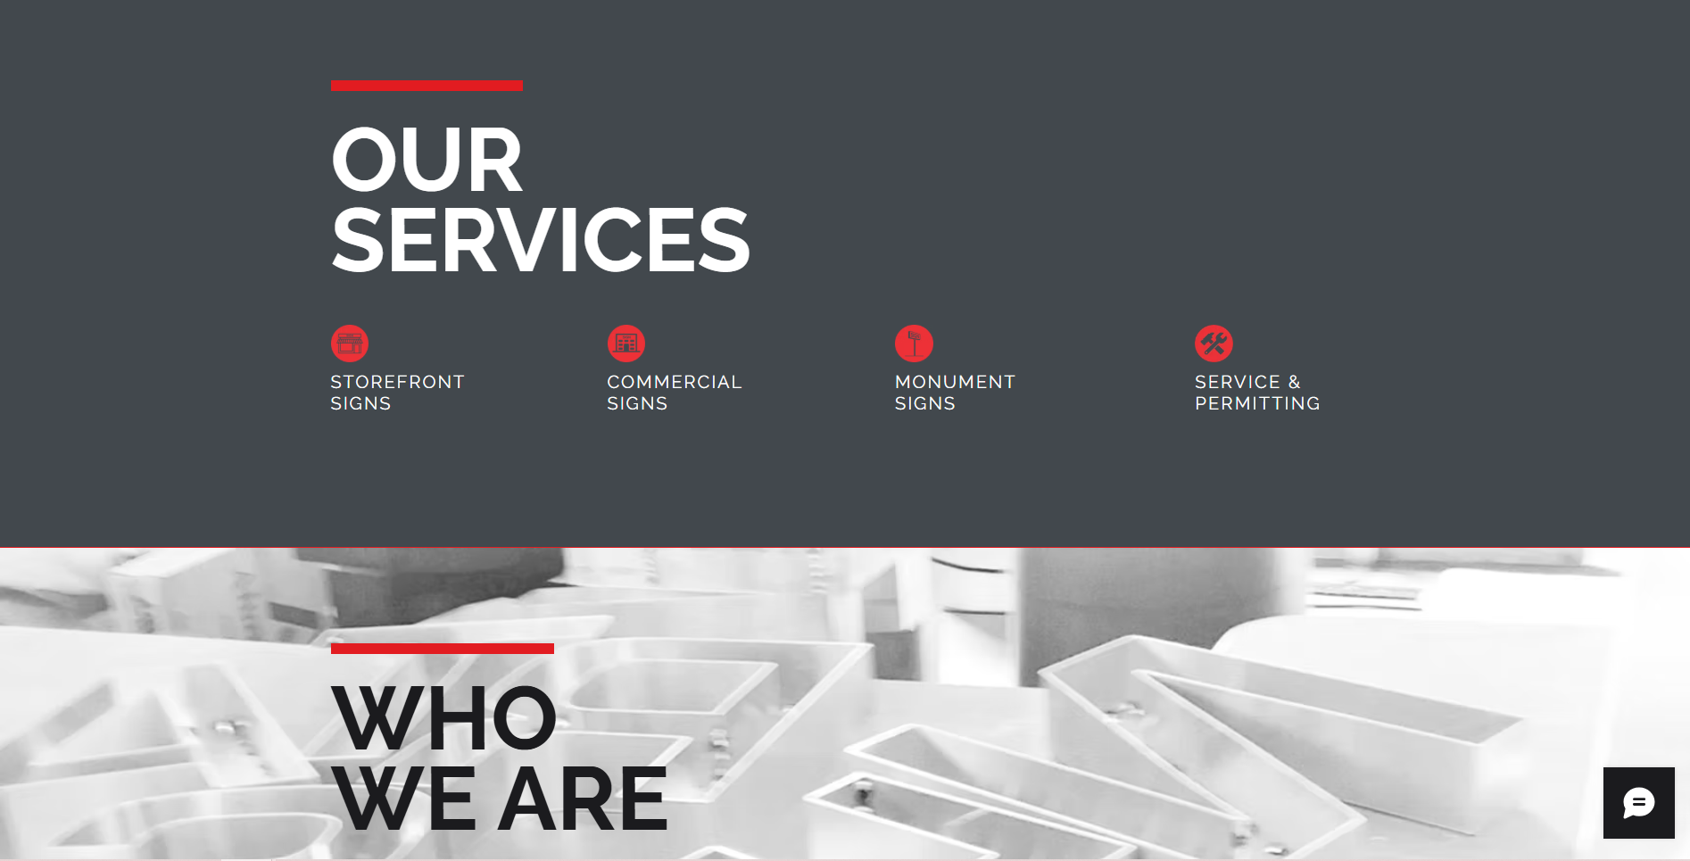

* **Bad Things in the Real Website**

1. **Poor Balance and "Dead Space":**
   * **The Issue:** The "OUR SERVICES" title is pushed to the far left, leaving about 60% of the screen as empty, dark gray space. This feels "unanchored" and visually lopsided.
   * **HCI Principle:** Balance and Symmetry in composition.
2. **Lack of Detail (Low Information Density):**
   * **The Issue:** The services only have a title and a tiny icon. A user might know they do "Commercial Signs," but they don't know *what* kind or *how* the process works. It forces the user to click (if they even can) to find basic information.
   * **HCI Principle:** **Recognition vs. Recall.** we want to give enough info so the user *recognizes* the service they need immediately without searching.
3. **Weak Visual Grouping:**
   * **The Issue:** The icons and titles are just floating. There is nothing visually binding the "Icon" to the "Text," making it feel like a loose list rather than a professional menu of options.
   * **HCI Principle:** **Gestalt Principle of Proximity.** Related items should be visually grouped.
4. **Jarring Background Transitions:**
   * **The Issue:** The transition from the flat gray "Services" section to the busy, photo-background "Who We Are" section is very abrupt. The black text on the busy photo background can also cause readability issues for some users.

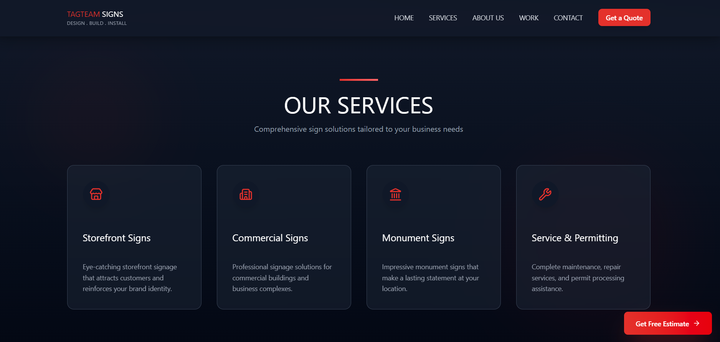

* **How we fix these issues**
* **Centered Hierarchy:**
  + **What we did:** Centered the "OUR SERVICES" title and added a descriptive sub-headline.
  + **Why it works:** This creates a focal point in the middle of the screen (the "Golden Ratio" area), making the page feel grounded and intentional.
* **Implementation of "Card UI":**
  + **What we did:** we placed each service into a defined "Card" with its own background, icon, title, and **descriptive text**.
  + **Why it works:** This uses the **Gestalt Principle of Enclosure**. By putting the information in a box, we tell the brain: "Everything inside this box belongs together." It makes the information much easier to scan and digest.
* **Increased "Information Scent":**
  + **What we did:** Added 2–3 lines of descriptive text under each service.
  + **Why it works:** In HCI, "Information Scent" is the user's ability to guess what they will find if they dig deeper. By adding descriptions, we provide a stronger "scent," which reduces user frustration and helps them decide where to click next.
* **Persistent Action (Sticky CTA):**
  + **What we did:** we added a "Get Free Estimate" button that likely stays visible or appears at the end of the section.
  + **Why it works:** It follows **Fitts's Law**—making the goal (the button) large and easy to find once the user has finished reading about the services.
* **Clean, Modern Iconography:**
  + **What we did:** Used modern, uniform line-art icons that match the brand's aesthetic.
  + **Why it works:** **Consistency and Standards.** It makes the site look like a cohesive product rather than a collection of random clip-art.

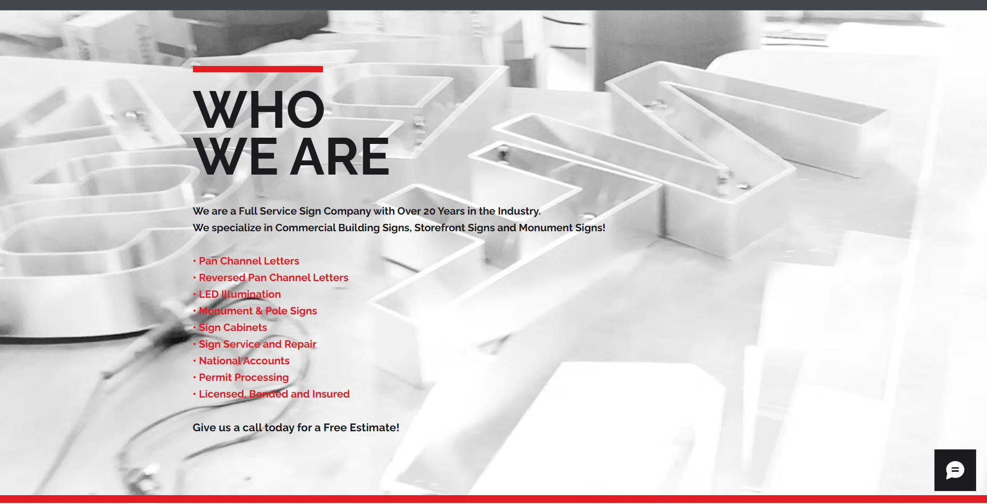

* **Bad Things in the Real Website**
* **Readability and Accessibility Issues:**
  + **The Issue:** The black and red text is placed directly over a complex, high-contrast black-and-white background image. The lines of the image intersect with the letters, making it physically difficult for the eye to distinguish text from the background.
  + **HCI Principle:** **Signal-to-Noise Ratio.** The "Signal" (the text) is being drowned out by "Noise" (the busy background image).
* **Poor Scannability:**
  + **The Issue:** The bulleted list is a single long vertical column. On modern widescreen monitors, this creates "long line lengths" and wasted horizontal space, forcing the user to scroll more than necessary.
  + **HCI Principle:** **Scan-pattern Optimization.** Users rarely "read" websites; they "scan" them. A long single-column list is inefficient for quick scanning.
* **Lack of Emotional Connection:**
  + **The Issue:** The background image is a washed-out, clinical-looking shot of sign frames. It feels cold and industrial.
  + **HCI Principle:** **Emotional Design.** Imagery should evoke a feeling of "quality" or "humanity." The original fails to build a "brand personality."
* **Ineffective Call-to-Action (CTA):**
  + **The Issue:** "Give us a call today for a Free Estimate!" is just a line of plain text at the bottom. It doesn't look like an interactive element, so users might ignore it.
  + **HCI Principle:** **Affordance.** Elements should look like what they do. A call to action should "afford" clicking by looking like a button or a distinct block.

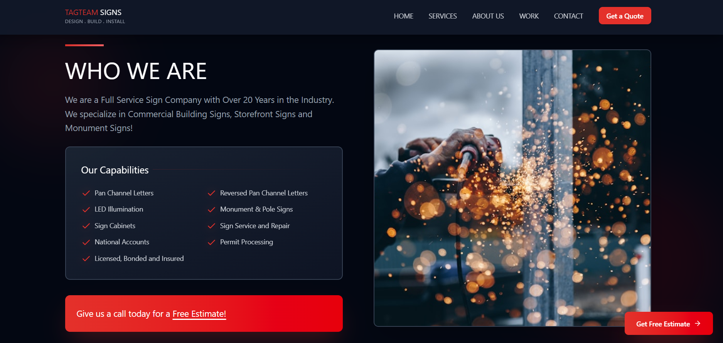

* **How we fixed these issues**
* **Contrast and Legibility:**
  + **What you did:** You moved the text to a solid dark background and used a high-quality, colorful image on the right.
  + **Why it works:** By separating the text from the image, you've maximized the **Signal-to-Noise Ratio**. The white text on a dark background provides excellent contrast, meeting **WCAG accessibility standards**.
* **Information Chunking (Dual-Column List):**
  + **What you did:** You organized the "Capabilities" into a two-column grid inside a subtle container.
  + **Why it works:** This follows **Miller’s Law** (chunking information to make it easier to process). It uses the horizontal space of the screen more effectively and allows the user to scan all capabilities at a glance without scrolling.
* **Visual Storytelling:**
  + **What you did:** You used a high-action, "sparkling" photo of someone actually working on a sign.
  + **Why it works:** This is **Aesthetic-Usability Effect**. Users perceive more attractive and professional-looking designs as easier to use and more trustworthy. The sparks and the human hands show "craftsmanship," which sells the service better than a pile of metal frames.
* **Defined CTA Blocks:**
  + **What you did:** You turned the "Free Estimate" text into a bright red, high-visibility banner/button at the bottom left.
  + **Why it works:** You’ve created strong **visual affordance**. The red color is a "learned convention" from the brand, and its shape clearly marks it as a clickable or important zone.
* **Alignment and Balance:**
  + **What you did:** You aligned the "Who We Are" header with the previous sections' grid.
  + **Why it works:** **Consistency.** By keeping the layout consistent as the user scrolls down, you reduce the "Cognitive Load" required for the user to understand where the information is located on each new section.

* **Bad Things" in the Real Website**
* **Visual Overload and "The Red Wall":**
* **The Issue:** The entire top half is a solid block of high-saturation red. In HCI, this is known to cause "**Visual Fatigue**." Large areas of bright red can be physically uncomfortable to look at for more than a few seconds, which might cause a user to scroll away quickly without reading the text.
* **HCI Principle: Accessibility & Ergonomics**. Colors should be used to highlight, not to overwhelm the entire field of vision.
* **Low "Information Scent" in the Gallery:**
  + **The Issue:** The photos are just a grid of images. A potential customer looking at "Kung Fu" or "azWHOLEistic" doesn't know *what* service they are seeing (e.g., is it a Channel Letter sign? A vinyl banner? A monument sign?).
  + **HCI Principle:** **Recognition vs. Recall.** The user shouldn't have to guess or remember what the company offers while looking at the gallery; the design should tell them exactly what they are looking at
* **Lack of Navigation/Engagement Cues:**
  + **The Issue:** There is no "View More" button or filter. The user is left with a static wall of photos and no clear way to explore more specific categories of work.
  + **HCI Principle:**User Control and Freedom. A gallery should allow the user to explore or navigate deeper into a portfolio.
* **Poor Text Contrast & Layout:**
* **The Issue:** The white text on the red background meets minimum contrast, but the long, wide paragraph of text is difficult to scan. It’s a "wall of text" that most users will skip.

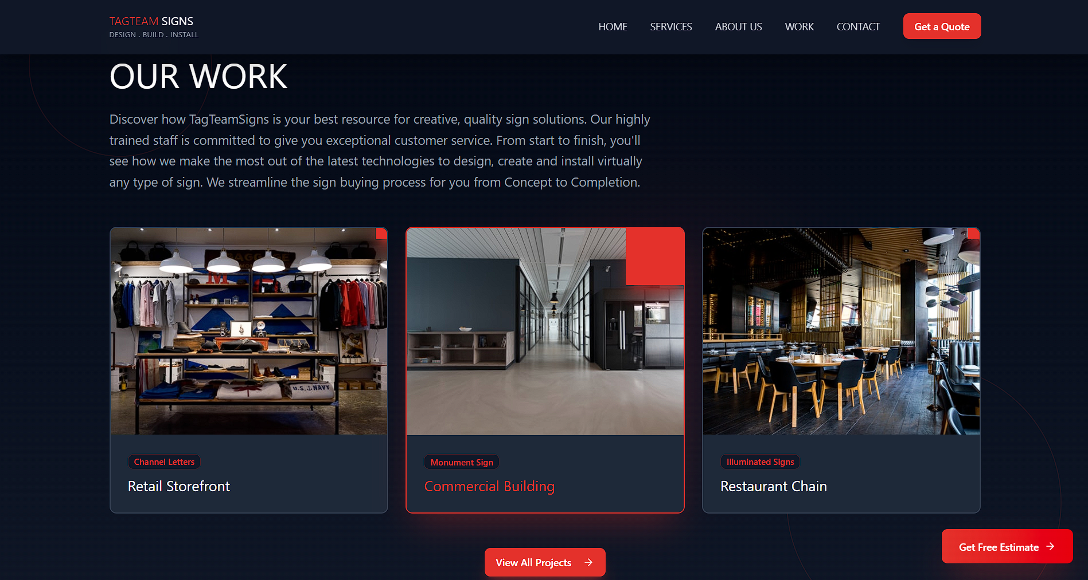

* **How we fixed this issues:**
* **Aesthetic and Minimalist Design (Dark Mode):**
* **What we did:** Switched to a dark theme where the red is used as an **accent** (in the titles and tags) rather than a background.
* **Why it works:** It follows **Nielsen’s 8th Heuristic (Aesthetic and Minimalist Design).[1][2]** By reducing the "background noise," you allow the colorful photos of the actual signs to become the focal point.
* **Implementation of Categorization (Tags):**
* **What we did:** We added red labels on the images (e.g., "Channel Letters," "Monument Sign").
* **Why it works:** This provides a strong "Information Scent." Users can immediately identify the service type. It maps the company's capabilities directly to the visual proof.
* **Clear Call-to-Action (CTA):**
* **What you did:** You added a "View All Projects" button centrally and a persistent "Get Free Estimate" button.
* **Why it works:** This follows **Fitts’s Law** (making the target large and easy to reach).[3][4][5][6][7] You’ve given the user a clear "exit path" from this section to the next step in the sales funnel.
* **Visual Grouping and Enclosure:**
* **What you did:** Each image is now part of a card with a title and description.
* **Why it works:** This uses the **Gestalt Principle of Common Region**. By boxing the image and text together, the user naturally perceives them as a single related unit of information.

* **Bad Things" in the Real Website**
* **Confusing Color Semantics:**
* **The Issue:** The placeholder text inside the form fields (e.g., "Name," "Email") is bright red.
* **HCI Principle: Mental Models.** In digital interfaces, red text inside a box almost always signals an **error.** Using red for standard instructions creates "false alarms" in the user's brain, making them feel like they've already done something wrong before they even start typing.
* **Redundant Labeling (Visual Noise):**
* **The Issue:** Every field has a label above it ("Enter Your Name *") AND a placeholder inside it ("Name").
* **HCI Principle: Signal-to-Noise Ratio.** By repeating the same information twice for every box, the interface becomes cluttered. This increases the "interaction cost" because the user has more to read and filter out.
* **Weak Affordance (The Submit Button):**
* **The Issue:** The "Submit" button is small, dark, and tucked into a corner. It doesn't look like the most important thing on the page.
* **HCI Principle: Fitts's Law**. The most important action (submitting) should be a large, high-contrast target. In the original, it is physically small and visually "hidden."
* **Missing Critical Information:**
* **The Issue:** There is no physical address or business hours.
* **HCI Principle:** Trust and Credibility. Users often look at a contact page to verify if a business is local or to see when they can visit. Without this, the business feels less "real."

* **How we fixed this issues:**
* **Improved Semantics and Legibility:**
* What you did: Switched placeholder text to a subtle, neutral gray and removed the redundant top labels.
* Why it works: It follows the Principle of Least Astonishment. The gray text is non-threatening and clears away "noise," making the form feel much lighter and easier to fill out.
* **Logical Grouping (Gestalt Principle of Enclosure):**
* **What you did:** You separated the **Form** from the **Contact Information** using a distinct card with a dark background.
* **Why it works:** You’ve grouped related items (Phone, Email, Hours) together. This helps the user’s brain "chunk" the information, so they can find exactly what they need without scanning the whole page.
* **Standardized Iconography:**
* **What you did:** Added recognized icons for Phone, Email, and Location.
* **Why it works:** Icons act as **Visual Anchors**. Users can recognize a "phone" icon faster than they can read the word "Phone," which speeds up the scanning process.
* **Strong Primary Action (CTA):**
* **What you did:** Created a wide, bright red "Send Message" button with a "paper plane" icon.
* **Why it works:** This is a clear **Affordance**. The button is the most vibrant thing on the page, telling the user's eye exactly where to go once the form is done. The icon provides a "hint" of what happens next (sending).
* **Adding Context (Business Hours & License):**
* **What you did:** Explicitly listed hours and added "Licensed, Bonded and Insured" in the footer.
* **Why it works:** It builds **User Trust**. By answering questions before the user even asks them (e.g., "Are they open now?"), you reduce the user's cognitive strain.